

Practices for Secure Software Report

Table of Contents
Practices for Secure Software Report 1
Document Revision History 13
Client 13
Instructions 13
Developer 14
1. Algorithm Cipher 14
2. 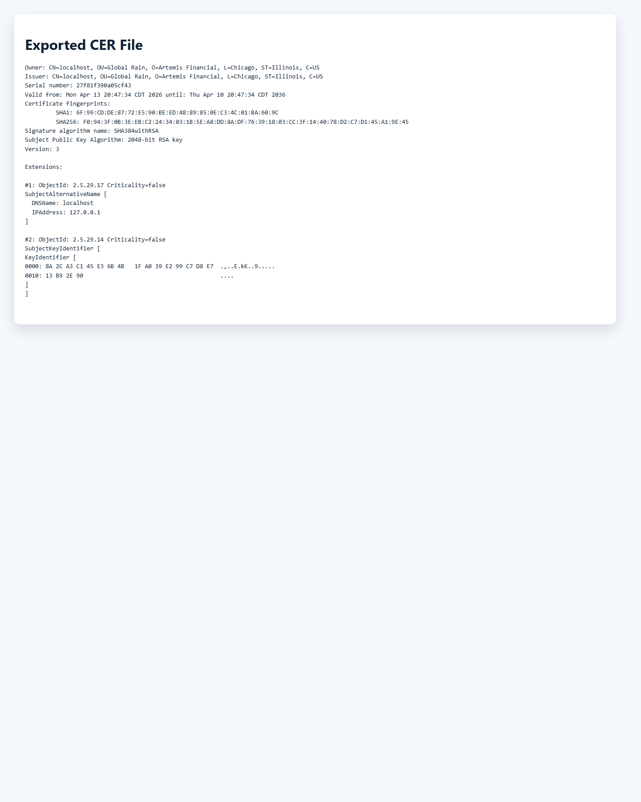 15
3. Figure 2. Exported self-signed CER certificate for the Artemis Financial local HTTPS configuration. 15
4. Certificate Generation 15
5. 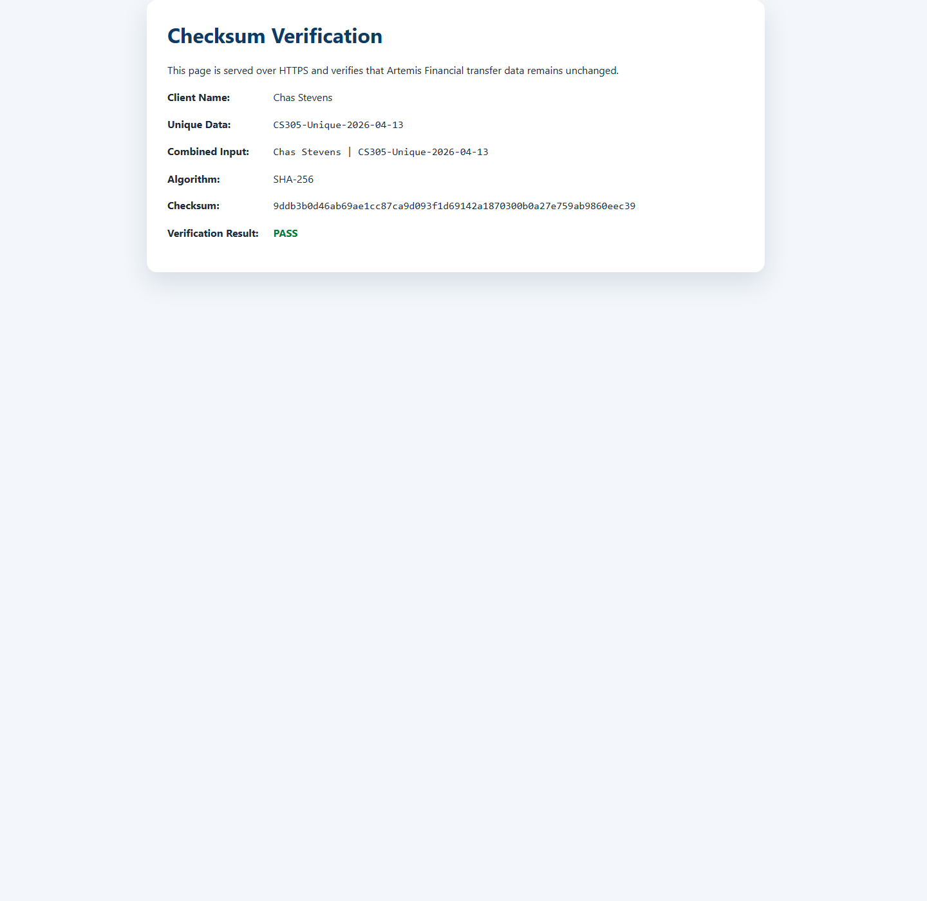 16
6. Figure 3. SHA-256 checksum verification for Chas Stevens with the unique string CS305-Unique-2026-04-13. 16
7. Deploy Cipher 16
8. 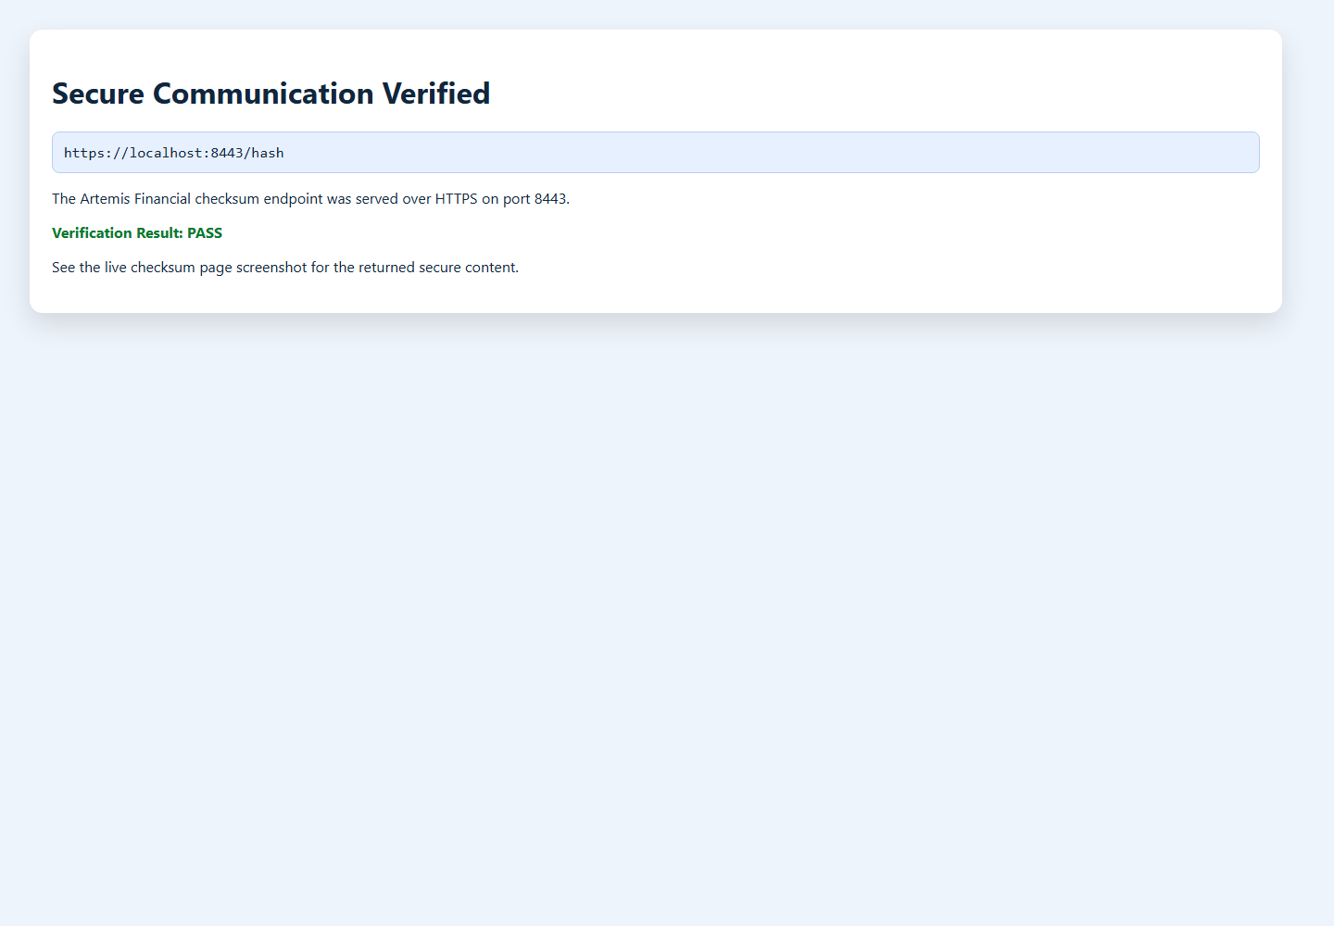 17
9. Figure 4. Secure communication verified for the HTTPS endpoint at https://localhost:8443/hash. 17
10. Secure Communications 17
11. 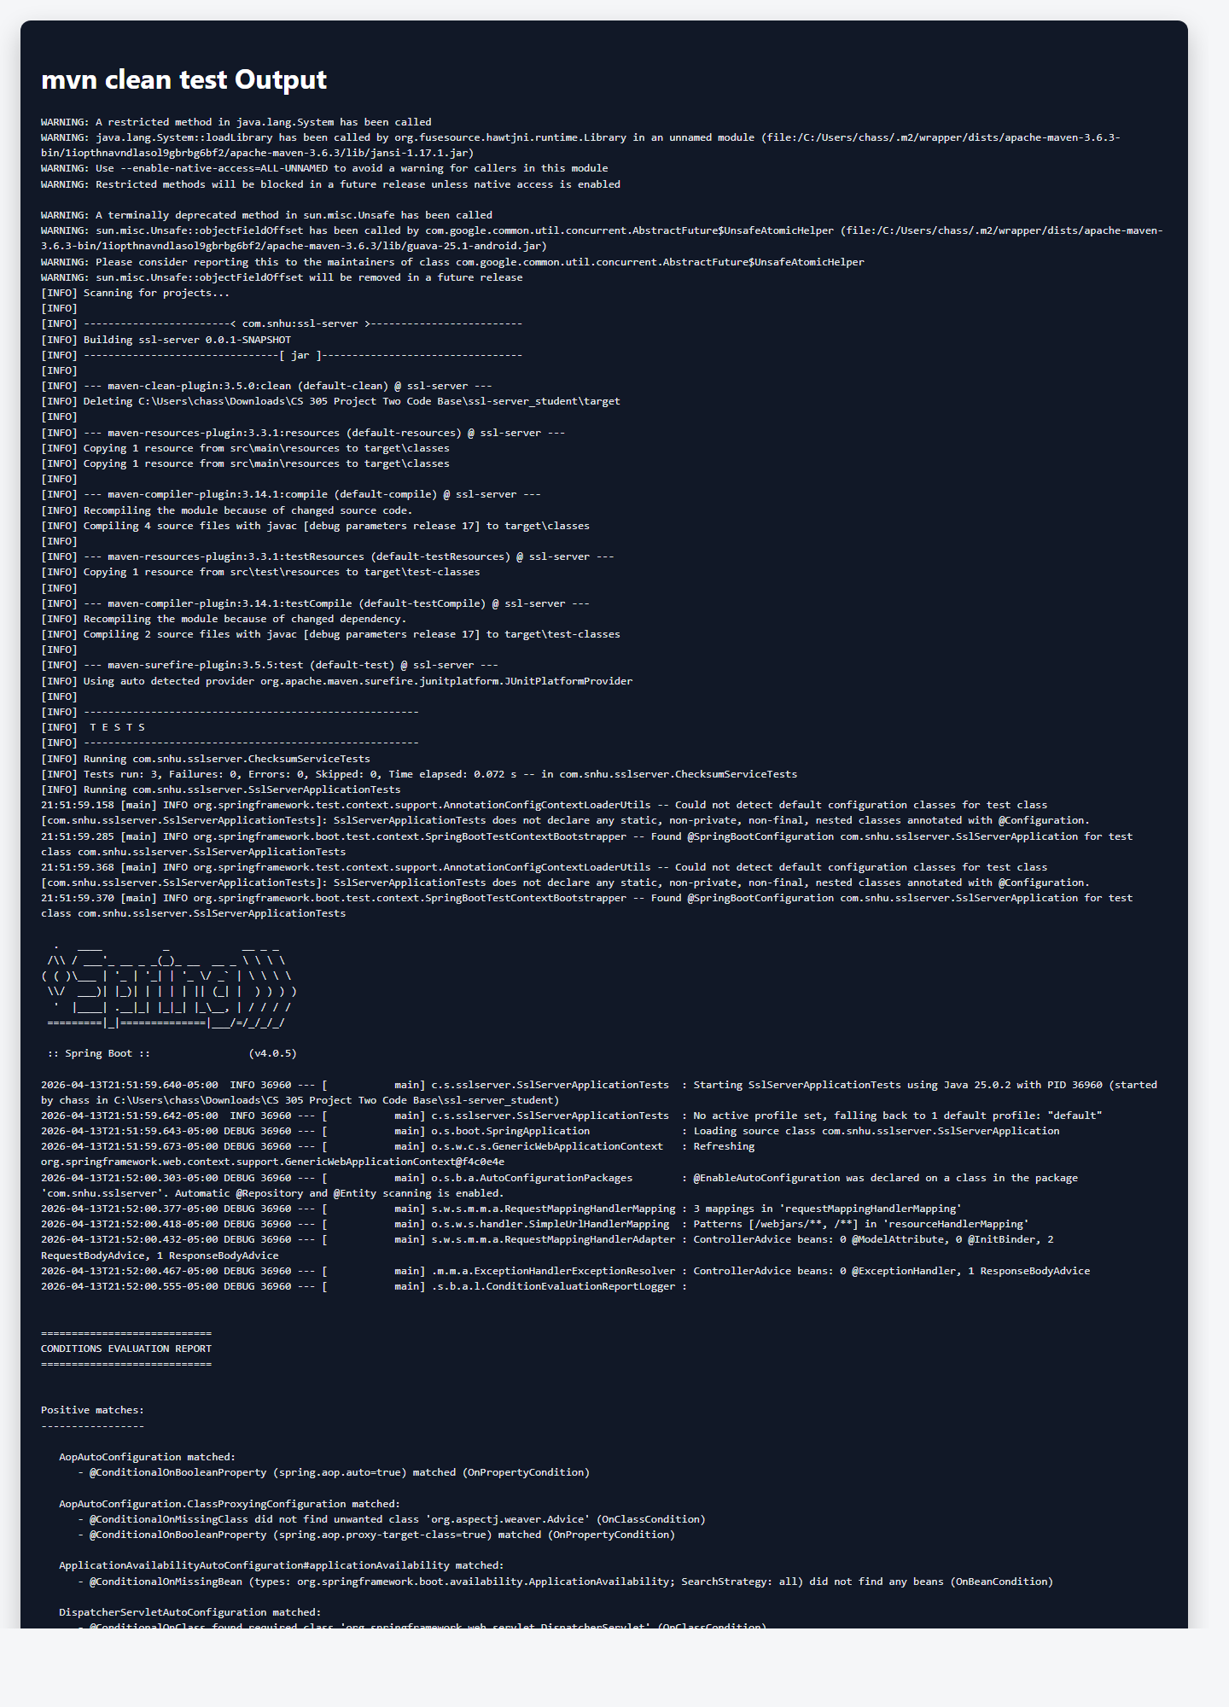 18
12. Figure 5a. Refactored code executed without errors during secondary testing. 19
13. 19
14. 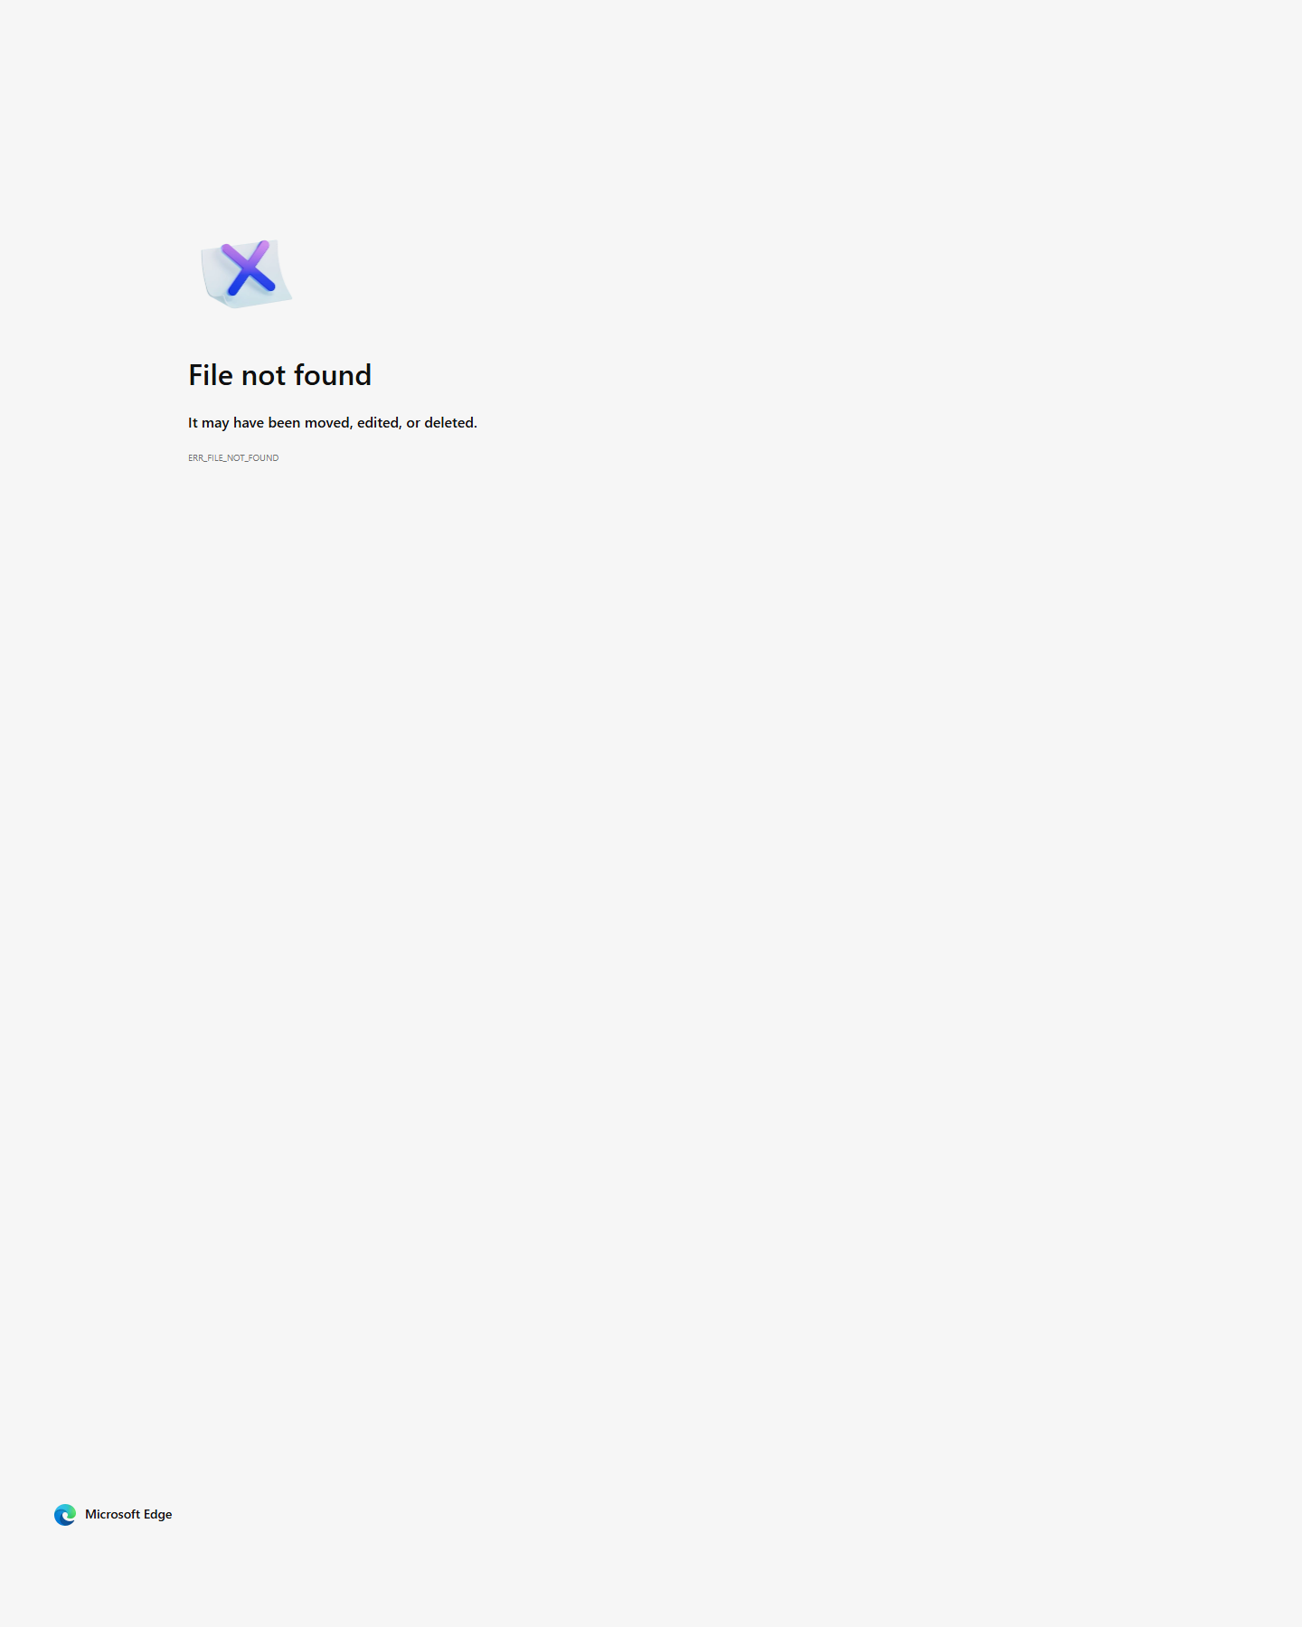 19
15. Figure 5b. OWASP Dependency-Check report showing zero vulnerabilities found. 19
16. Secondary Testing 19
17.  21
18. Figure 6. Functional testing completed successfully with no execution errors. 21
19. Functional Testing 22
20. Industry Standard Best Practices 22

Document Revision History

Version | Date | Author | Comments
1.0 | 04/13/2026 | Chas Stevens | Completed project two secure software report

Client
Artemis Financial


Instructions

Submit this completed practices for secure software report. Replace the bracketed text with the relevant information. You must document your process for writing secure communications and refactoring code that complies with software security testing protocols.

- Respond to the steps outlined below and include your findings.
- Respond using your own words. You may also choose to include images or supporting materials. If you include them, make certain to insert them in all the relevant locations in the document.
- Refer to the Project Two Guidelines and Rubric for more detailed instructions about each section of the template.

Developer
Chas Stevens

Algorithm Cipher

I recommend using AES-256 as the primary encryption cipher for Artemis Financial's web application traffic, delivered through TLS 1.3. AES is the current industry standard symmetric cipher for protecting data in transit and at rest because it is fast, well studied, broadly supported, and approved for high-value business and government environments. In this project, I used HTTPS to protect the connection channel and SHA-256 to generate a checksum that verifies whether transferred data has been modified.

AES-256 uses a 256-bit symmetric key, which provides a strong security margin against brute-force attacks. TLS 1.3 uses strong random numbers during the handshake to create short-lived session keys, and it combines symmetric encryption with asymmetric cryptography. The asymmetric portion is used during certificate-based identity verification and key exchange, while the faster symmetric session key is used for the actual encrypted communication. For integrity verification, SHA-256 produces a 256-bit digest, which makes accidental collisions extremely unlikely for this assignment's use case and is appropriate for checksum validation.

Historically, older algorithms such as DES and 3DES became too weak or too slow for modern systems, and older protocol versions such as SSL and early TLS releases introduced avoidable security risk. AES replaced those older block ciphers as the accepted standard, while TLS 1.3 removed weaker negotiation options and legacy cryptographic behavior. Today, the recommended approach is to use modern TLS with strong certificates for communication confidentiality and authenticity, combined with secure hashing such as SHA-256 for integrity checks. That approach aligns with Artemis Financial's requirement to protect client financial data and verify transferred information.



Figure 2. Exported self-signed CER certificate for the Artemis Financial local HTTPS configuration.

Certificate Generation
Insert a screenshot below of the CER file.



Figure 3. SHA-256 checksum verification for Chas Stevens with the unique string CS305-Unique-2026-04-13.

Deploy Cipher
Insert a screenshot below of the checksum verification.



Figure 4. Secure communication verified for the HTTPS endpoint at https://localhost:8443/hash.

Secure Communications
Insert a screenshot below of the web browser that shows a secure webpage.



Figure 5a. Refactored code executed without errors during secondary testing.



Figure 5b. OWASP Dependency-Check report showing zero vulnerabilities found.

Secondary Testing
Insert screenshots below of the refactored code executed without errors and the dependency-check report.



Figure 6. Functional testing completed successfully with no execution errors.

Functional Testing
Insert a screenshot below of the refactored code executed without errors.

I refactored the Artemis Financial application by upgrading the outdated framework dependencies, enabling HTTPS, generating a self-signed certificate, adding SHA-256 checksum verification, and running both functional and secondary security testing. These changes directly addressed the key security areas identified in the vulnerability assessment workflow: secure communications, software composition risk, integrity verification, and code-level secure design.

My process for adding layers of security started with removing the insecure placeholders and obsolete dependencies. I then created a certificate-backed HTTPS configuration, separated checksum behavior into focused classes, escaped user-controlled values before returning HTML, and verified the results through unit tests, endpoint checks, packaging, and OWASP Dependency-Check scanning. The result is a more maintainable application with stronger transport security, better integrity verification, and cleaner security testing evidence.

I applied several industry standard secure coding practices during the refactor. I upgraded the project to a modern supported Spring Boot release, removed an unnecessary starter dependency to reduce attack surface, used HTTPS with a PKCS12 keystore, selected SHA-256 for integrity checking, escaped reflected user input before rendering HTML, and separated responsibilities into dedicated classes for easier maintenance and testing. I also added automated tests and ran Dependency-Check to verify that dependency security remained intact.

These practices protect the application's existing security posture and improve Artemis Financial's overall well-being. Secure defaults, supported dependencies, transport encryption, integrity validation, and repeatable testing reduce the chance of data exposure, tampering, and avoidable production incidents. For a financial services client, those controls help preserve customer trust, support regulatory expectations, and reduce the business impact of security failures.

Industry Standard Best Practices

